**Coal lab 06**

Name: Syed Muzzamil Waseem

SID: 11067

Question 1

CODE:

INCLUDE Irvine32.inc

.data

;Syed Muzzamil Waseem 11067

msg1 byte "Enter 10 numbers: ",0

msg2 byte "Sum of 10 numbers is: ",0,0dh,0ah

var1 dword 10 dup(?)

.code

main PROC

mov ecx, 0

mov edx, offset msg1

call writestring

call crlf

.while ecx<10

call readint

mov var1[ecx*4], eax

inc ecx

.endw

mov ecx, 0

.while ecx<9

add eax, var1[ecx*4]

inc ecx

.endw

call crlf

mov edx, offset msg2

call writestring

call writedec

call crlf

exit

main ENDP

END main

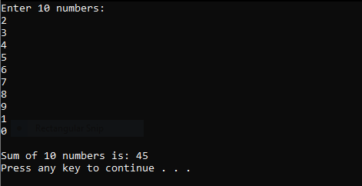

Question 2

CODE:

INCLUDE Irvine32.inc

.data

;Syed Muzzamil Waseem 11067

msg1 byte "Enter 5 numbers: ",0,0dh,0ah

msg2 byte "Average of 5 numbers is: ",0,0dh,0ah

var1 dword 5 dup(?)

.code

main PROC

mov ecx, 0

mov edx, offset msg1

call writestring

call crlf

.while ecx<5

call readint

mov var1[ecx*4], eax

inc ecx

.endw

mov ecx, 0

.while ecx<5

add eax, var1[ecx*4]

inc ecx

.endw

call crlf

mov edx, offset msg2

call writestring

mov edx, 0

mov ebx, 5

div ebx

call writedec

call crlf

exit

main ENDP

END main

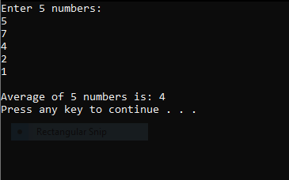

Question 3

CODE:

INCLUDE Irvine32.inc

.data

;Syed Muzzamil Waseem 11067

array BYTE 50 DUP (0)

myMsg BYTE "Enter 5 numbers: ",0

.code

main PROC

mov edx, offset myMsg

call writestring

mov ecx,0

.while (ecx<5)

call readdec

mov array[ecx],al

inc ecx

.endw

call crlf

mov ecx,4

.while(ecx<5)

mov al,array[ecx]

call writedec

call crlf

dec ecx

.endw

exit

main ENDP

END main

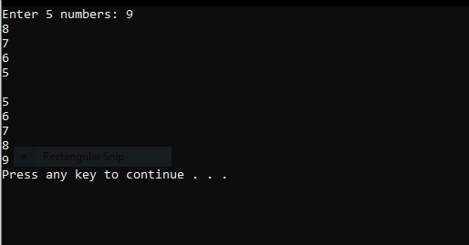

Question 4

CODE:

INCLUDE Irvine32.inc

.data

;Syed Muzzamil Waseem 11067

myMsg BYTE "Enter 5 values: ",0

List BYTE 11,7,89,4,0,10

ListSize = ($ - List)

.code

main PROC

mov eax,ListSize

call writeint

call crlf

exit

main ENDP

END main

